- Opportunity
(a)

(b)
Figure 1: Autonomous material handling vehicles (AMHVs) operating in: (a) a warehouse, and (b) a factory.

Warehouses and factories are being transformed by automated guided vehicles and autonomous mobile robots, collectively called autonomous material handing vehicles (AMHVs), which swiftly pick and carry material from one place to another, dynamically navigating obstacles and human co-workers using localization and maps, and dramatically increasing productivity (Fig. 1). Amazon alone has more than 200,000 AMHVs in its nearly 110 warehouses [1], and the number of AMHV-powered warehouses is projected to increase over ten-fold to 50,000 globally over the next five years (Fig. 2) [2,3].
Since these AMHVs are used indoors and cannot be tethered, they are powered electrically by an onboard battery. The limited energy capacity of batteries is a major hurdle in achieving the full productivity benefits of AMHVs. Currently, these vehicles are taken offline and plugged in for recharging, or their drained batteries are swapped with pre-charged ones. Both approaches impose substantial additional costs and require additional space due to the need for spare vehicles or batteries. An alternative approach is to charge AMHVs wirelessly from the floor while they are performing their tasks, including when they are in motion, i.e., dynamic wireless charging. This substantially increases productivity and reduces the need for on-board batteries (decreasing costs).
- State of the Art and Research Objectives
Figure 2: Projected growth in number of AMHV-powered warehouses [3].
Researchers have traditionally focused on inductive wireless charging, which uses magnetic field coupling between coils, to transfer energy [4-11]. A major shortcoming of inductive wireless charging is that for magnetic flux guidance and shielding, it requires expensive and brittle ferrite cores, making it expensive, bulky, and difficult to embed in the warehouse or factory floor [12]. My group has recently developed a capacitive approach for wireless charging that utilizes electric field coupling between plates to transfer energy [13,14]. The relatively directed nature of electric fields eliminates the need for ferrites or dielectric materials, allowing the capacitive system to be much smaller, lighter, less expensive, and easier to embed in the floor (Fig. 3a). We have demonstrated a 300-W proof-of-concept dynamic capacitive wireless charging system that is suitable for in-motion charging and which validates our predictions (Fig. 3b) [15].
The objective of the proposed research is to dramatically improve the cost-performance tradeoff for dynamic wireless charging systems through fundamental advancements in high-power dynamic capacitive wireless charging systems, develop a full-scale 3.7-kW dynamic capacitive wireless charging system capable of in-motion charging of AMHVs, and utilize this to demonstrate the techno-economic feasibility of delivering high constant power at high efficiencies to vehicles traveling at speeds appropriate for AMHVs in warehouses and factories. This objective will be achieved through a number of innovations proposed in this research, and the proposed research will create new knowledge on the frontier of charging technologies for AMHVs.
Figure 3: Dynamic (in-motion) capacitive wireless charging system for AMHVs: (a) conceptual drawing showing plates embedded in the floor delivering power to AMHV plates, and (b) photograph of our 300-W proof-of-concept prototype.
- Innovative Nature of Proposed Research
Due to the very small capacitance between the floor and the vehicle charging plates, effective power transfer in capacitive wireless charging systems can only occur at very high frequencies (in the multi-MHz range), and requires the use of matching networks that provide appropriate voltage/current gain and reactive compensation. In a dynamic scenario, the capacitive coupling between the floor and vehicle plates is constantly changing, making the design of these systems extremely challenging. The dynamic capacitive wireless charging system proposed here will be made possible by a number of innovations and fundamental advancements, including:
(i) Innovative matching network designs that absorb parasitic capacitances and leverage these capacitances to enhance power transfer. A major roadblock in the development of high power transfer density capacitive wireless charging systems is the presence of multiple parasitic capacitances that can overwhelm the coupling capacitance between the ground and the vehicle pad and severely degrade power transfer and efficiency. We propose a new approach to address this challenge by employing split-inductor matching networks, which allow the complex network of parasitic capacitances in the AMHV charging environment to be simplified into an equivalent four-capacitance model that can be directly utilized as part of the matching network.
(ii) A novel coupler design—metacoupler—that enables electric field focusing to achieve enhanced safety and electromagnetic interference (EMI) immunity. The fields emanating from the charging system must stay below levels prescribed by regulatory and industry bodies. To enable transferring high power levels without safety and EMI concerns, we propose the use of couplers having metasurfaces with specific surface-impedance distribution to reduce fringing fields. This new approach to near-field focusing has extraordinary promise and will be thoroughly developed and evaluated through analytical analysis, simulations and experimental measurements.
(iii) A new rectifier architecture—active variable reactance (AVR) rectifier—that can compensate for large misalignments and distance variations, and maintain constant output power and high efficiency as the AMHV moves over the charging pad. Another major innovation proposed here is related to the architecture, topology and control of the high-frequency power electronic converters suitable for in-motion wireless charging. We introduce novel “active variable reactance” (AVR) rectifiers comprising multiple rectifiers and appropriate resonant tanks that can compensate for large changes in coupling, while maintaining high power transfer capability and efficiency.
- Value Proposition and Impact
Dynamic capacitive wireless charging of AMHVs opens a new opportunity for cost reductions in warehouses and factories through increased productivity. Table 1 presents a preliminary cost analysis comparing wired and dynamic capacitive wireless charging of AMHVs in a warehouse environment, showcasing the potential for 42% cost reduction with dynamic capacitive wireless charging. The costs associated with AMHVs and their charging infrastructure are computed based on a warehouse requiring 100 AMHVs operating full time; each AMHV costing $30k and having a 15-kWh battery for wired and a 3-kWh battery for dynamic wireless charging; battery costs of $150/kWh; AMHVs operating 50% of the time with wired charging and 100% of the time with dynamic wireless charging; wired charger costs of $750 per 7.5-kW charger and wireless charger costs of $750 per 3.7-kW charging pad (the lower power rating for dynamic charging is appropriate as the vehicle has more time to charge); and ten times larger number of wireless charging pads than wired chargers. While this analysis is preliminary, it is conservative at least in terms of the cost of AMHVs, which can exceed a $150k. Hence, dynamic capacitive wireless charging has the potential to accelerate the adoption of autonomous material handling vehicles by making them less expensive, truly autonomous, and more productive. This will revolutionize warehouse and factory automation.
Table 1: Potential cost savings with dynamic wireless charging in a warehouse requiring 100 AMHVs operating all the time.
Dynamic capacitive wireless charging systems have considerable advantages over inductive systems. The proof-of-concept dynamic capacitive wireless charging prototype we have developed is substantially lighter and easier to embed in the ground than its inductive counterpart (see comparison of couplers in Fig. 4a). For example, the coupling pad of the 3.6-kW inductive wireless charger from Plugless [16] has a thickness of 6.35 cm, while the projected thickness of a 3.7-kW capacitive coupling pad is 0.75 cm. The capacitive wireless charging approach is especially suited for AMHVs since the capacitive couplers’ lower profile, compared to inductive couplers (which require ferrite backing), allows it to easily fit in the limited space underneath the AMHV chassis; and a tile-flooring like approach could be taken to deploy a dynamic capacitive wireless charging system in a warehouse or factory.
Dynamic capacitive wireless charging systems have additional advantages over inductive counterparts. For instance, the power delivered by typical inductive wireless chargers falls to 10% of full power when the vehicle and charger are laterally misaligned by 100% (Fig. 4b). By comparison, the capacitive system with the proposed AVR rectifier can deliver full power even under 100% misalignments. Hence, dynamic capacitive wireless charging systems will require fewer and further-spaced charging pads to deliver the same amount of energy as an inductive system, making the proposed technology even more cost-effective.
(a)
(b)
Figure 4: Comparison of inductive and capacitive wireless charging: (a) couplers, and (b) power transferred to a moving vehicle by an inductive, a capacitive, and a capacitive with AVR wireless charging system.
- Research Plan and Technical Approach
To achieve the objective of a high-power dynamic capacitive wireless charging system capable of in-motion charging of AMHVs, three research thrusts have been formulated. In Thrust 1, we explore the design-space for capacitive wireless power delivery and leverage matching networks that absorb parasitic capacitances to enable compact wireless chargers with efficiencies comparable to wired counterparts. In Thrust 2, we explore the design-space of capacitive couplers with near-field focusing and leverage novel metacouplers with field sculpting ability to achieve high power transfer while meeting safety and EMI requirements. In Thrust 3, we focus on the control and system optimization of dynamic capacitive wireless chargers and leverage the new AVR rectifier architecture to deliver constant power to moving AMHVs. These three thrusts will collectively result in the development and demonstration of a 3.7-kW dynamic capacitive wireless charging system capable of in-motion charging of AMHVs.
5.1 Thrust 1: Capacitive Wireless Power Delivery utilizing Split-Inductor Matching Networks
The goal of Thrust 1 is to understand the design-space for capacitive wireless power delivery from the perspective of power electronics and resonant matching networks, and develop a compact, effective, and efficient capacitive wireless power delivery system. To achieve this goal, we will leverage our innovation in the design of matching networks that enable effective power transfer and address the following research questions: What are the design tradeoffs between charger size, power transfer capability and efficiency? How does system size and performance scale with output power? What is the optimal operating frequency for capacitive wireless charging of AMHVs?
State of the Art and Research Need: Power transfer in a capacitive wireless charging system is achieved using two pairs of coupling plates, with one pair embedded in the floor and the other in the vehicle chassis. These plate pairs are separated by a relatively large air-gap (equal to the vehicle’s ground clearance), resulting in a very small coupling capacitance (Figs. 5 and 3a). An inverter converts the dc input voltage to a high-frequency ac voltage, which is fed into a matching network that steps up the voltage to a high level at the floor side and partially compensates for the large capacitive reactance of the coupling plates. This high voltage (shown as $v_{p}$ in Fig. 5) enables high power transfer across the air-gap with low displacement current (shown as $i$ in Fig. 5), and hence, low voltage and electric fields across the air-gap, making the system safe. On the vehicle side, a second matching network steps the current back up (and the voltage down) to the level required to charge the vehicle battery. This matching network also provides the remaining compensation for the coupling reactance. A rectifier then interfaces the system to the vehicle battery. The small coupling capacitance necessitates operating at high frequencies, so that the reactance of the coupler is small enough to be effectively compensated. Wide-bandgap semiconductors (GaN and SiC) devices with fast switching speeds enable this high frequency operation.
Figure 5: Capacitive wireless charging system.
The capacitive coupling mechanism is modeled using two capacitors $C_{plate}$ in Fig. 5. This simple representation is found to be inadequate when a practical vehicle charging environment is considered. As shown in Fig. 6a, apart from the desired capacitances between the coupling plates ($C_{plate}$), 15 additional parasitic capacitances exist in this system. These additional capacitances originate from cross-coupling between the plates, as well as from coupling between two plates on the same side, the plates and the floor, the plates and the vehicle chassis, the floor and the vehicle chassis, the floor and the inverter ground, and the vehicle chassis and the rectifier ground. Many of these parasitic capacitances can be comparable to or even larger than the coupling capacitance, and can severely degrade power transfer (see Fig. 6a bottom two charts). Therefore, there is a need for an approach that enables effective power transfer in the face of these parasitic capacitances.
Figure 6: Practical vehicle charging environment for a capacitive wireless charging system with: (a) conventionally designed matching networks and degraded power transfer, and (b) proposed split-inductor matching networks which absorb and leverage parasitic capacitances to enhance power transfer.
Proposed Approach, Fundamental Advancements and Preliminary Results: Instead of being penalized by the parasitic capacitances, we have developed an approach to leverage the parasitic capacitances as part of the matching networks and achieve effective power transfer. Three parasitic capacitances (one between vehicle chassis and rectifier ground, another between floor and inverter ground, and another between floor and vehicle chassis) provide relatively low impedance paths for the inverter output current to return to the inverter ground without charging the vehicle battery. To ensure that no current flows through these parasitic capacitances, the inductors of the matching networks are split symmetrically into two halves, with one half placed in the forward path, and the other in the return path (see Fig. 6b circuit diagram). By symmetry, the ac component of the voltages appearing across these three capacitances are zero, which prevents any parasitic currents from flowing through them. The complex network of the remaining active parasitic capacitances can then be reduced to a 4-capacitance network of known values through two-port network transformations (see Fig. 6b) [17]. Since the shunt capacitances in the 4-capacitance model appear in parallel with the matching network capacitors, they can either be absorbed into the matching networks or can fully realize the matching network capacitances, as in Fig. 6b.
By utilizing the parasitic capacitances for power transfer and eliminating the need for discrete high-voltage capacitors system reliability is also enhanced, and size and cost decreased. The effectiveness of the proposed approach has been validated using circuit simulations, and by building a capacitive wireless dc-to-ac power delivery system with discrete-capacitor-free matching networks (Fig. 7a). The system’s architecture is similar to that of Fig. 5, except it does not have the high-frequency rectifier and battery and instead has a resistive load. The capacitive coupler of the prototype system is constructed from 22-cm diameter circular plates separated by a 12-cm air-gap. The system operates at 13.56 MHz and transfers up to 3.7 kW at 94.7% efficiency, achieving a power transfer density of 49.4 kW/m², which is ten times higher than the best competing capacitive wireless charging systems.
Under this thrust, we will further leverage my group’s earlier work on analytical optimization techniques for the design of efficient matching networks to determine the gain and impedance characteristics of the split-inductor matching networks to maximize system efficiency [18].
Figure 7: Prototype of our capacitive wireless dc-to-ac power delivery system: (a) photograph, and (b) measured efficiency.
5.2 Thrust 2: Capacitive Couplers utilizing Meta-Surfaces for Focused Near-Field Energy Transfer
The goal of Thrust 2 is to explore the design-space of capacitive couplers that achieve near-field focusing and leverage coupler designs utilizing metasurfaces to drastically reduce the fringing fields from wireless charging systems. This approach has the potential to enable transferring much larger levels of power without the safety or EMI concerns associated with high fringing fields. Major questions to be addressed here include: What are the limits to near-field sculpting that are possible with metasurfaces? What impedance distributions lead to maximum beneficial near-field sculpting? How can these impedance distributions be realized in capacitive couplers and what are the tradeoffs between the different implementation options? In the future, the PI also plans to build a collaboration with Prof. Francesco Monticone of Cornell University (who is an expert in applied electromagnetics and metamaterials) on some aspects related to metasurfaces.
State of the Art and Research Need: The fringing electric fields of wireless charging systems must remain within safe levels (as defined by the International Commission on Non-Ionizing Radiation Protection [19]) in areas occupied by people and animals (e.g., outside the perimeter of the vehicle chassis). Past approaches to reducing fringing fields in capacitive wireless charging systems have focused on using dielectric materials for field guidance. These approaches introduce additional losses and have limited success in medium-range applications. We have explored alternative techniques that have traditionally been used for beamforming in radars and other far-field applications [20]. We have developed a near-field phased-array field-focusing approach that uses multiple phase-shifted capacitive wireless charging modules to achieve dramatic reductions in fringing fields [13]. We have shown that a 180°-outphased configuration yields a progressive reduction in fringing electric fields as the number of modules increases [21]-[23]. While this multi-modular approach works well for stationary wireless charging systems, it is difficult to adapt for a dynamic system given the relative phasing needed for adjacent modules as the vehicle is moving. Thus, a passive approach to reduce the fringing fields that uses a single module would be extremely beneficial.
Proposed Approach, Fundamental Advancements and Preliminary Results: Our proposed solution to this problem is illustrated in Fig. 8. Convex curved plates are known to reduce the lateral extension of fringing fields due to their non-planar charge distribution; however, they would occupy a much larger space, which is problematic for AMHV applications. We propose to use the concept of metasurfaces to realize the same fringing-field distribution of two curved plates but using planar “meta-plates.” Since for capacitive wireless charging systems the frequency is moderately high, the problem is better modeled with full-wave Maxwell’s equation rather than electro-quasi-static approximations. Then, as commonly done in the design of metasurfaces [24], electromagnetic equivalence principles can be invoked to determine the required effective currents on a planar surface that would produce the same field distribution existing between arbitrarily curved plates. The required surface-impedance distribution of the metasurface that would sustain such currents is then easily determined, and it can be implemented with different techniques (usually based on patterning a metallic surface). Our preliminary field-intensity simulations show a dramatic fringing-field reduction (see Fig. 8). More broadly, during this project, we will fully explore the many opportunities offered by metasurfaces to “sculpt” the field distribution for maximizing the efficiency of compact dynamic capacitive wireless charging systems.
(a)
(b)
Figure 9: Capacitive wireless charging pad: (a) with insulating cover, and (b) without cover showing the two charging plates.
We have also conducted some preliminary experiments with differently patterned capacitive coupling pads (similar in geometry to those shown in Fig. 9) to understand the potential for fringing-field reduction in near-field wireless systems. The initial experimental results show meta-couplers exhibiting lower fringing fields. We will explore this opportunity deeply under this thrust.

Figure 10: Comparison of measured fringing electric fields from a conventional coupler and a meta-coupler.
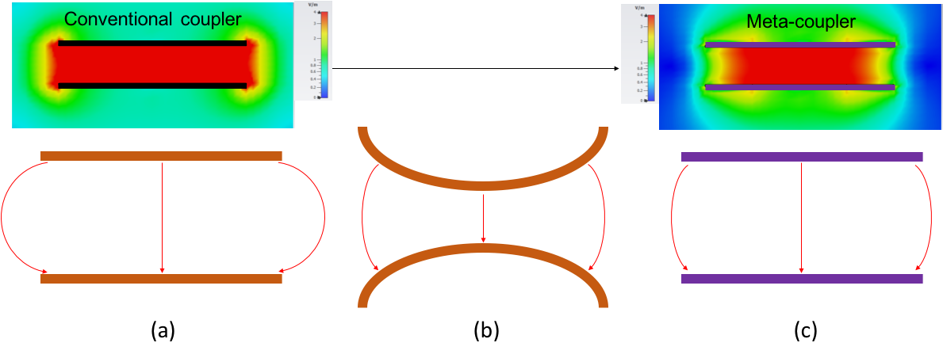
Figure 8: Alternative coupler designs: (a) passive flat metal plates, (b) curved metal plates, and (c) metasurface plates with same fringing field distribution as curved metal plate but clearance of the flat plate. Preliminary field-intensity simulations with metasurface (top right) show dramatic fringing-field reductions relative to flat metal plate (top left).
5.3 Thrust 3: Dynamic Wireless Charging System Control and Optimization
The goal of Thrust 3 is to deepen our understanding of the design-space for the new AVR rectifier architecture, and combine this knowledge with Thrust 1 and Thrust 2 efforts to optimize, design, build and test a high-power dynamic capacitive wireless charging system capable of delivering continuous power to moving AMHVs. The optimized system design would use system specifications also gathered in this thrust. The AVR rectifier related major questions to be addressed are: What are the tradeoffs between misalignment (and air-gap variation) tolerance, system size and efficiency. How far apart should charging pads be placed to achieve an optimal tradeoff between power pulsations and systems costs? How do these tradeoffs scale with system power level? Can multiple charging pads be powered from the same power electronics to reduce costs, and if so what constraints does this architecture impose?
State of the Art and Research Need: To achieve effective power transfer, wireless charging systems need to operate close to the resonant frequency of the resonant tank formed by the reactances of the coupler and the matching network. However, the coupler reactance depends on the vehicle’s road clearance, and varies as the vehicle moves across the charger (see Fig. 11). The drift between resonant and operating frequency causes a reduction in power transfer and efficiency of the wireless charging system. In wireless charging systems operating at low frequencies (below 100 kHz), where bandwidths are not restrictive, the traditional approach to dealing with variations in coupling is to change the operating frequency to track the resonance frequency of the system [25,26]. However, in MHz-frequency wireless charging systems the operating frequency must stay within one of the narrow designated industrial, scientific and medical (ISM) bands (e.g., 6.78 MHz, 13.56 MHz and 27.12 MHz) [27]. One solution that is employed in low-power (up to a few Watts) MHz-frequency inductive WPT systems is to use a bank of capacitors that can be switched in and out of the compensating network, so as to keep the resonant frequency roughly unchanged in the event of coupling variations [28]. However, this is not an effective approach for higher power wireless charging systems as the switches have to be much larger and more expensive to keep the system efficient. Furthermore, this approach is less suited to capacitive wireless charging systems, as it requires multiple switchable compensating inductors which are larger and more lossy than capacitors. Other adaptive impedance matching techniques include the use of saturable and variable inductors [29], but these techniques reduce system efficiency and do not scale well with power.
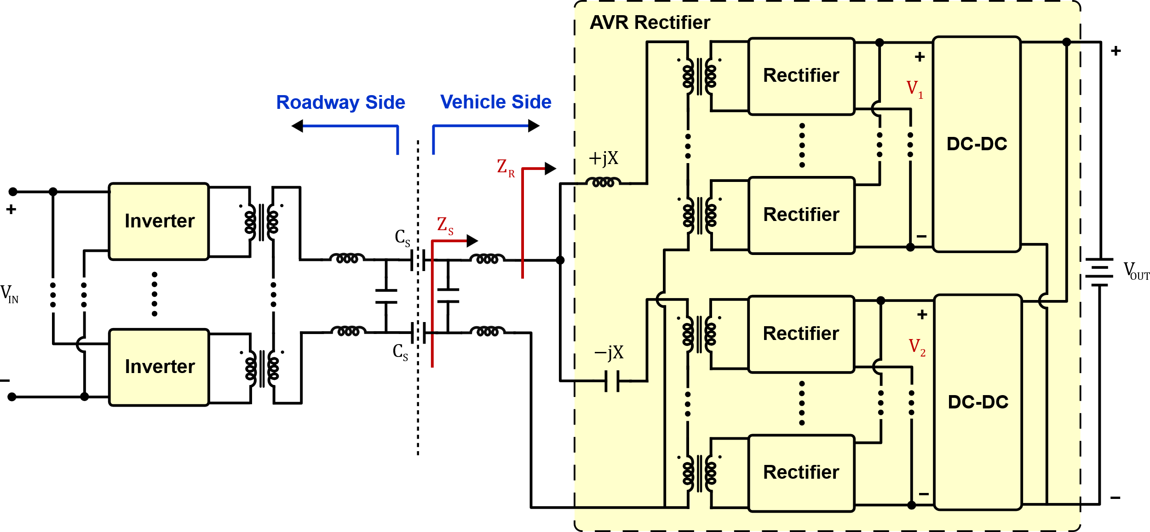
Figure 12: Power-scalable dynamic capacitive wireless charging system incorporating an active variable reactance (AVR) rectifier
Figure 11: Variation in coupling between floor and vehicle pads due to different vehicle clearances and change in vehicle position as it passes over the charger.
Proposed Approach, Fundamental Advancements and Preliminary Results: We have developed a new high-frequency rectifier architecture—the Active Variable Reactance (AVR) rectifier—that compensates for coupling variations while operating at a fixed frequency and maintaining high efficiency [30]. A capacitive wireless charging system incorporating an AVR rectifier is shown in Fig. 12. The AVR rectifier comprises a power-splitting resonant network with two branches having equal and opposite reactances: an inductive branch $+jX$ and a capacitive branch $-jX$. To make the system power-scalable, transformers connect a number of inverters on the roadway side in parallel and a number of rectifiers in parallel on each branch of the AVR rectifier on the vehicle side. Each branch of the AVR rectifier is tied to the system output through two dc-dc converters, designed to regulate their input voltages $V_{1}$ and $V_{2}$. By appropriately controlling these two voltages, the AVR rectifier can provide continuously variable compensation while maintaining optimum soft-switching of the rectifiers, ensuring high efficiency. This compensation architecture ensures that the output power of the wireless charging system is maintained at a fixed level across wide variations in coupling (see Fig. 4b).
(a)
(b)
Figure 13: Operation of the AVR rectifier showing: (a) required variation in rectifier output voltages, and (b) power processed by the two rectifiers as a function of coupler misalignment.

There are multiple possible implementations of the AVR rectifier, and we will explore its design-space to identify the approach most suitable for dynamic wireless charging. In one approach, when the coupling plates are fully aligned and at the minimum air-gap value, the matching networks fully compensate for the coupler reactance, and the dc-dc converters of the AVR rectifier operate in pass-through mode (i.e., $V_{1}=V_{2}=V_{OUT}$), so that the AVR rectifier does not provide any reactive compensation. In this case, the inductive and capacitive branches of the AVR rectifier each process half of the output power (see Fig. 13). When the plates are misaligned or the air-gap increases, the capacitive reactance of the coupler increases (by $ΔX_{s}$), and the matching networks can no longer provide sufficient compensation. This leads to a substantial fall in power transfer and efficiency. To mitigate this, the voltages $V_{1}$ and $V_{2}$ of the AVR rectifier are varied such that an inductive reactance $ΔX_{s}$ is added to the secondary-side impedance $Z_{sec}$ (see Fig. 12), while its real part remains the same. The additional inductive reactance ensures that the coupling variation is compensated, while the constant real part guarantees that the output power is maintained at a fixed level. The operation of the AVR rectifier is illustrated in Fig. 13 for an example design of a dynamic capacitive wireless charging system. As the misalignment increases in either direction, the input voltage of one of the dc-dc converters ($V_{1}$) is decreased, while that of the other ($V_{2}$) is increased. Consequently, the power processed by one of the dc-dc converters ($P_{1}$) decreases while that by the other ($P_{2}$) increases, maintaining a constant total output power.
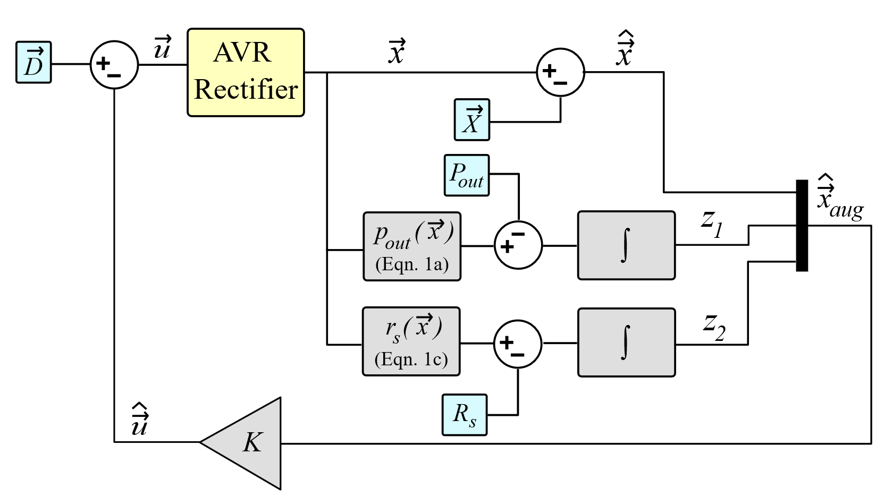
Figure 14: Block diagram of the proposed full-state-feedback control strategy for the AVR rectifier
Another important aspect that will be explored and developed is the control of the AVR rectifier. In the event of any misalignment, the AVR rectifier must satisfy two control objectives: (i) maintain a constant output power and (ii) compensate for the change in coupling reactance. Control objective (i) is easy to measure: simply measure the output voltage and current; their product will be the output power. Then, the controller just needs to drive this output power towards the desired value. Control objective (ii), at first glance, would require the measurement of the varying coupling reactance to compensate for deviations from the nominal coupling reactance. This is challenging to do accurately, since it involves sensing phase angles at high frequencies. However, it can be shown that this can be accomplished by holding the real part ($R_{sec}$) of the secondary-side impedance $Z_{sec}$ at its nominal value. The secondary-side input impedance $Z_{sec}$ can be found by first calculating the AVR input impedance $Z_{r}=\frac{V_{1}^{2}V_{2}^{2}+V_{OUT}^{2}I_{1}I_{2}X^{2}}{V_{OUT}\left(V_{1}^{2}I_{2}+V_{2}^{2}I_{1}\right)}+jX\frac{V_{2}^{2}I_{1}-V_{1}^{2}I_{2}}{V_{1}^{2}I_{2}+V_{2}^{2}I_{1}}$ , then transforming this impedance through the secondary-side matching network. All of these quantities do not fluctuate at the multi-MHz ISM band the inveters are operating at, so there is no longer a need for high-frequency sensing. Thus, the proposed strategy to accomplish the two control objectives is to simultaneously regulate $R_{sec}$ and the output power.
Finally, the proposed closed-loop controller that implements the stated control objectives is shown in Fig. 14 [31]. It is a time-domain full-state-feedback controller. To design it, a small-signal model of the AVR rectifier is derived. From it, an augmented state-space model is written, and then linearized at the nominal operating point of the system. The resulting augmented state-space model is shown below:

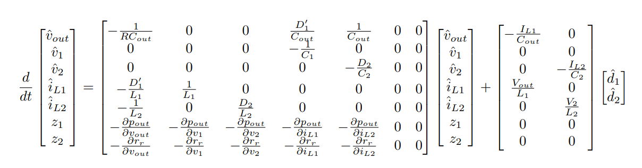
Using the augmented state-space model, an LQR problem is se up to design an optimal gains matrix $K$ which drives the measured output power and $R_{sec}$ to their nominal values.

To validate the AVR rectifier approach, we have built and tested a 300-W 13.56-MHz proof-of-concept dynamic capacitive wireless charging system which can compensate for large misalignments and distance variations. This prototype maintains constant output power for up to 45% coupler misalignment, and for air-gaps ranging from 12 cm to 17.4 cm, while maintaining high efficiency (see Fig. 15). We have also validated the proposed control strategy using a 65-W proof-of-concept dynamic capacitive wireless charging prototype using a 5.3 $Ω$ resistive load and a 200-MHz, 32-bit microcontroller. When the primary-side and secondary-side coupling plates are fully aligned to one another, and the dc-dc converters of the AVR rectifier operate in pass-through mode, the prototype system delivers 65 W across the air-gap, resulting in a voltage of 18.5 V across its resistive load. As the coupling plates are misaligned, the output power, and consequently the voltage across the load resistor falls. In order to test the operation of the closed-loop AVR rectifier, the plates are first misaligned by 30% with the dc-dc converters still kept in pass-through mode, and then the controller is turned on. The resulting waveforms of the system output voltage $V_{OUT}$, and the input voltages of the two dc-dc converters $V_{1}$ and $V_{2}$, are shown in Fig. 16. As can be seen, when the dc-dc converters are in pass-through, all three voltages are at 15.1 V, corresponding to an output power of 43 W. When the controller is turned on, the input voltage of the boost converter ($V_{1}$) falls to 7.2 V, and the input voltage of the buck converter ($V_{2}$) rises to 20 V, causing the output voltage to rise to its nominal value of 18.5 V, and the output power to its nominal value of 65 W, validating the operation of the proposed control strategy.
Figure 16: Measured waveforms of the output voltage and the input voltages of the dc-dc converters of the capacitive wireless charging prototype demonstrating closed loop operation of the AVR rectifier.
Figure 15: Measured output power of proof-of-concept 300-W dynamic capacitive wireless charging system with and without the AVR rectifier operation as a function of: (a) lateral misalignment, and (b) air-gap variation.
- Milestones and Schedule
This one-year research project will lead to the development of a full-scale 3.7-kW dynamic capacitive wireless charging system capable of in-motion charging of AMHVs, which will be tested using an appropriate mockup or an actual AMHV. The first task of the project will be to finalize the system requirements for the full-scale prototype based on a survey of representative AMHVs. In parallel to this activity, a study of the design-spaces for each of the three major elements of the dynamic capacitive wireless charging system (inverter/split-inductor matching network; meta-coupler; and AVR rectifier) will be carried out; to be followed by the design, building and testing of each of the components of the dynamic charging system. The system will be optimized as new knowledge is created and incorporated into our designs, and system integration will occur as the different components are realized and ready for system level testing. The schedule of the proposed research and the milestones associated with with each of the four quarters are shown in Fig. 17. The project will be conducted by the PI with the help of two graduate research assistants; one involved in Thrust 1, the other in Thrust 2, and both involved in Thrust 3.
- Expected Outcomes
Dynamic capacitive wireless charging for AMHVs (like the one shown in Fig. 18) presents a new opportunity for cost reductions in warehouses and factories through increased productivity. Our preliminary analysis suggests the possibility of substantial cost reductions through reduced downtime with the use of dynamic capacitive wireless charging instead of wired charging in warehouses. Our work to date demonstrates the tremendous potential of dynamic capacitive wireless charging systems in enabling efficient, high power transfer density, low profile, light weight, cost effective wireless charging of AMHVs from the warehouse or the factory floor. The proposed research will create new knowledge at the frontier of charging technologies for AMHVs, and the proposed technologies promise major improvements in power transfer capability, size, efficiency, range, and safety of dynamic wireless charging systems for AMHVs.

Figure 17: Schedule and milestones of the proposed research.
Successful completion of Thrust 1 will inform us about the design tradeoffs between charger size, power transfer capability and efficiency, as well as the optimal operating frequency for capacitive wireless charging of AMHVs. This knowledge will be used to design, built and test high-power high-efficiency capacitive power delivery systems which leverage innovative matching networks that absorb parasitic capacitances. The effort under Thrust 2 will deepen our understanding of the obtainable fringing field reduction using meta-couplers. Meta-coupler based capacitive power transfer systems will be built and tested to validate simulation results. Thrust 3 will help us understand the design-space for the AVR rectifier and enable us to design a controller with rapid enough response to track and deliver continuous power to moving AMHVs. The knowledge from all three thrusts will be combined to create the full-scale 3.7-kW dynamic capacitive wireless charging system for AMHVs with a target efficiency of 95%. This prototype will also serve as the platform to validate the techno-economic feasibility of a dynamic capacitive wireless charging system for AMHVs. By answering questions such as the optimal number and placement of wireless charging pads in a warehouse, this research will also provide the underlying knowledge needed to design optimized energy deliver and charging infrastructure for the material handling industry.
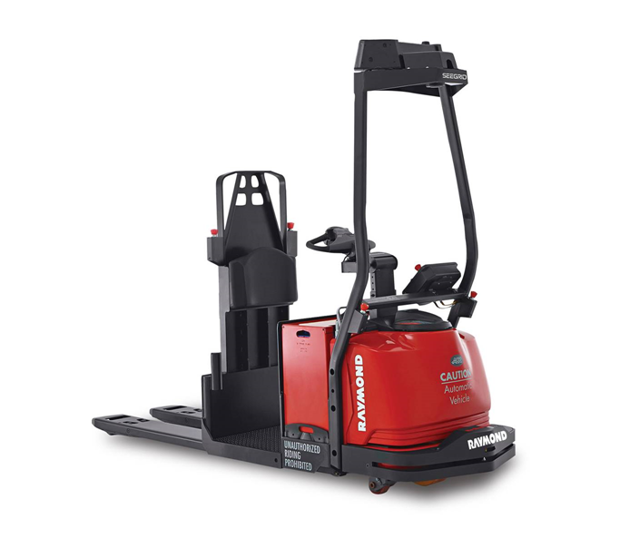
Figure 18: Example automated material handling vehicle (AMHV) that would benefit from the proposed research.

The advancements expected from this research would result in the need for fewer and further-spaced wireless charging pads, making the capacitive wireless charging technology even more cost-effective, and help accelerate the adoption of autonomous AMHVs by making them less expensive, truly autonomous, and more productive. This will revolutionize warehouse and factory automation.

